Finding the suspicious and harmful logs Using Event Viewer
- Overview
We will use Event Viewer tool to analyze system and security logs. Event Viewer records important system activities, including user login, application errors, and network activity. By analyzing these logs, we can identify suspicious or harmful activities such as failed login attempts, unusual user behavior, or unauthorized access.
- Objectives
- We will analyze Application, Security, System, set up, Forwarded Logs
- Step-by-step Implementation
Step 1 Open the Event Viewer in your machine
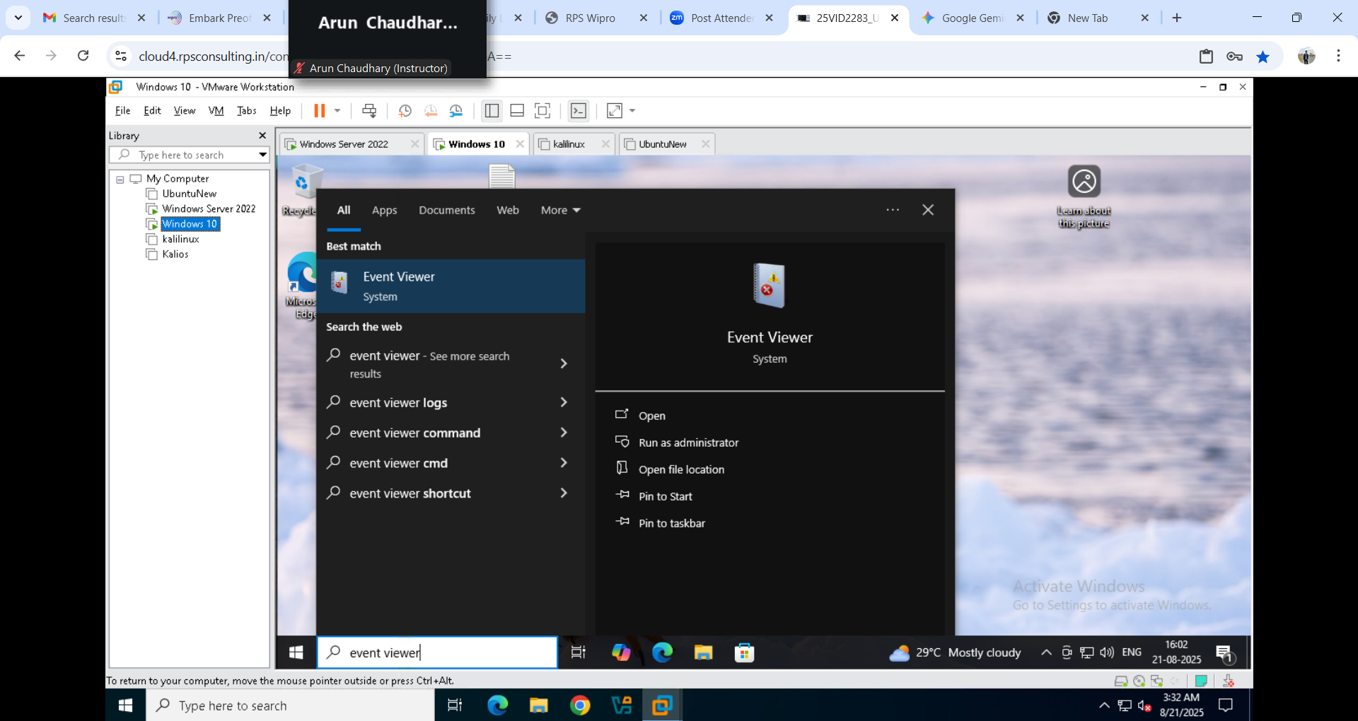
Step 2 Click on the Windows Logs , you will be seen different types
- Application – Here you can find application related logs
- Security – Here you can find the security & login event logs
- Setup – Here you can find the installation/upgrade related logs
- Forwarded – Here you can find the remote related logs
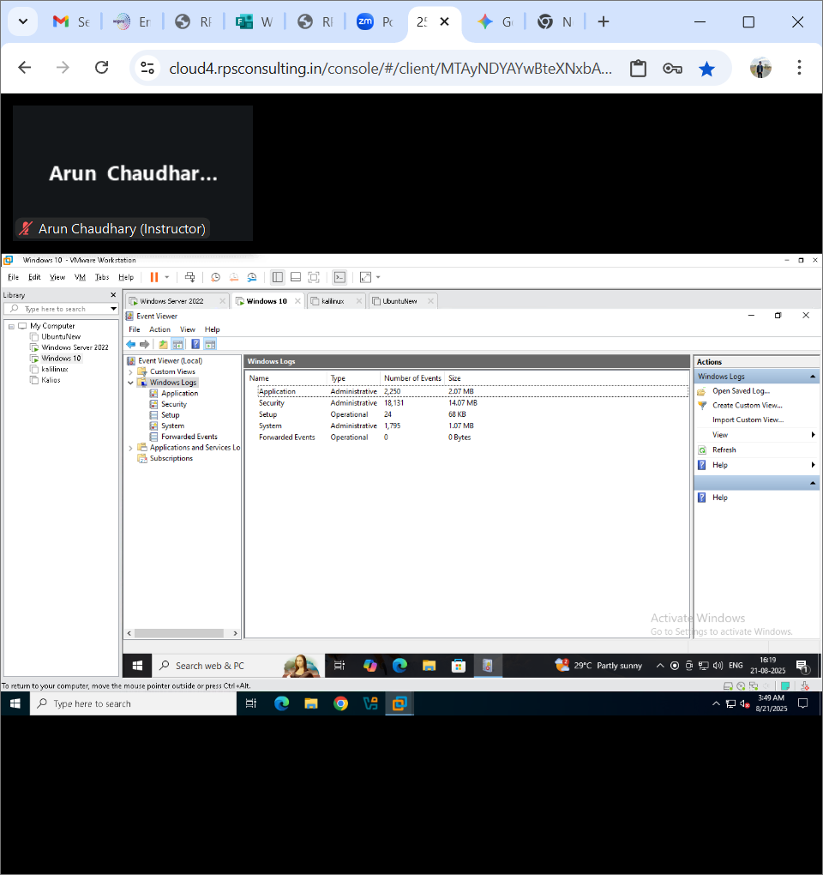

Step 3 click on Application and click on Filter Current Log [ right side ]
- Select Critical , Error and Warning
- Click ok
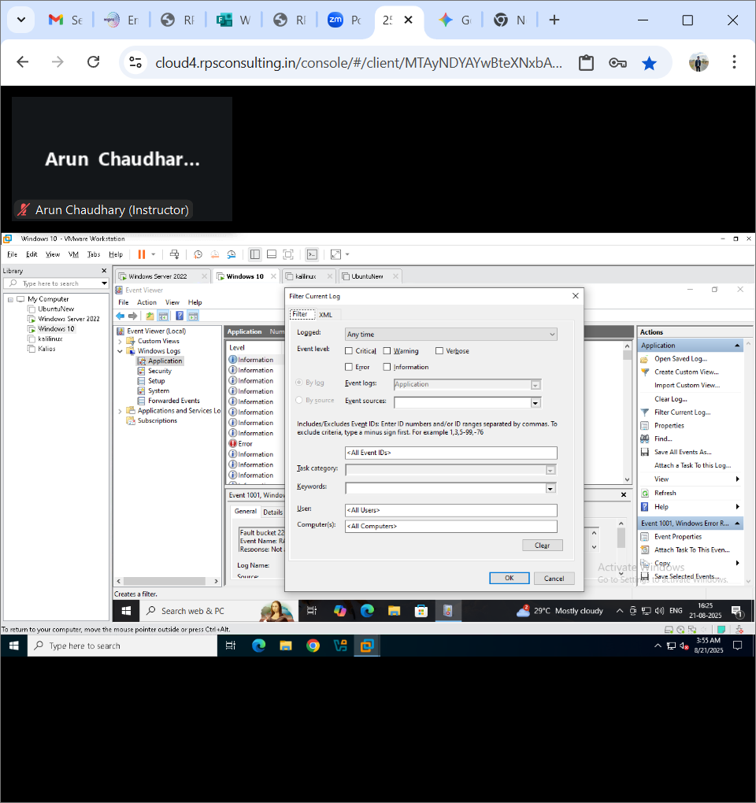

Step 4 Select any log and Right click on that log and Select Event Properties
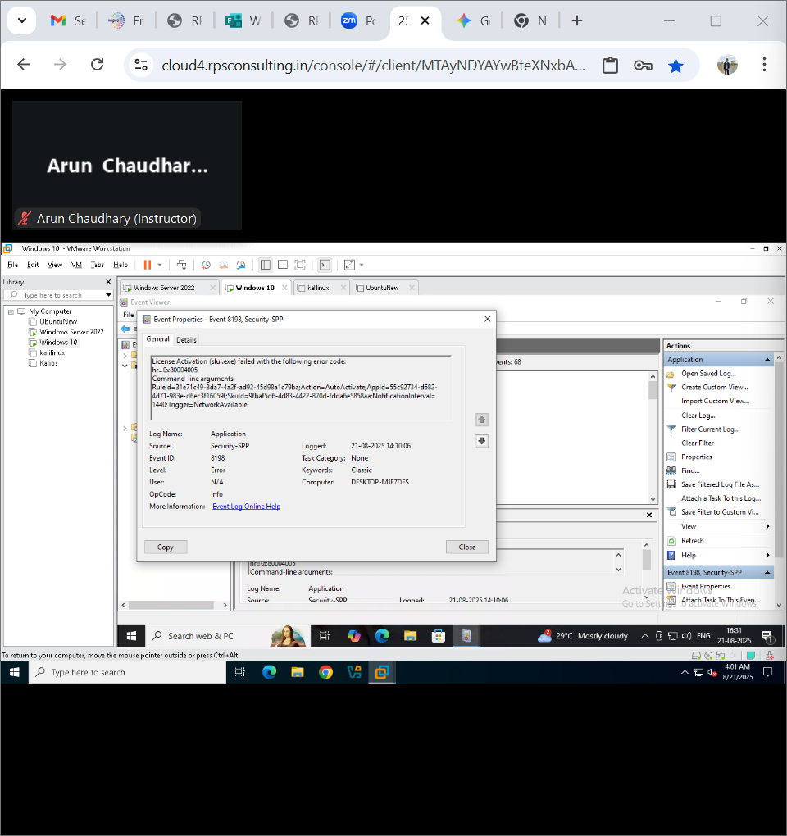
Event Id : 8198 – It is error with source "Microsoft-Windows-Security-SPP" in the Windows event logs typically indicates a failed Windows activation attempt. This event usually appears when the Software Protection Platform (SPP) tries to activate a Microsoft product (like Windows or Office) but encounters an issue preventing successful activation.

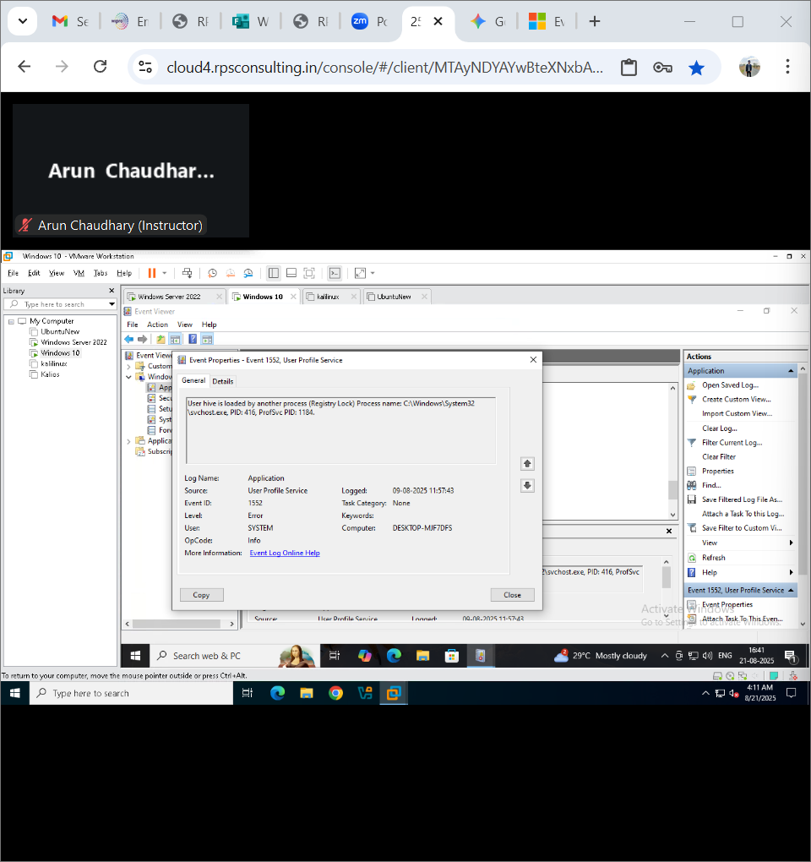
Event ID : 1552 – It indicates that another process has locked the user's registry hive, preventing the User Profile Service from loading or unloading the user's profile and leading to errors like temporary profiles or failed sign-ins
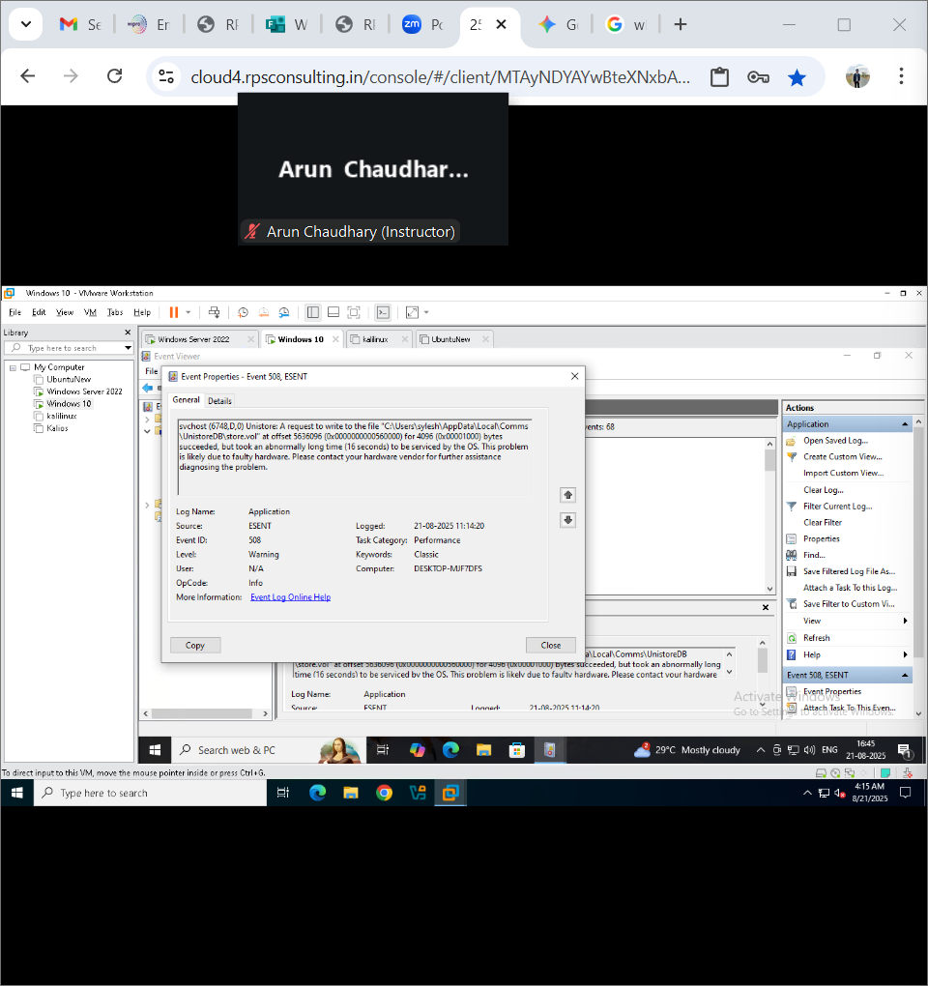
Event ID : 508 – It indicates a performance issue where the operating system takes an abnormally long time to service a write request to a file
Step 5 click on Security and click on Filter Current Log [ right side ]
Some common Event id’s
- Event ID 4624 – Successful logon
- Event ID 4625 – Failed logon
- Event ID 4672 – Privileged account logon
- Select Critical , Error and Warning
- Click ok
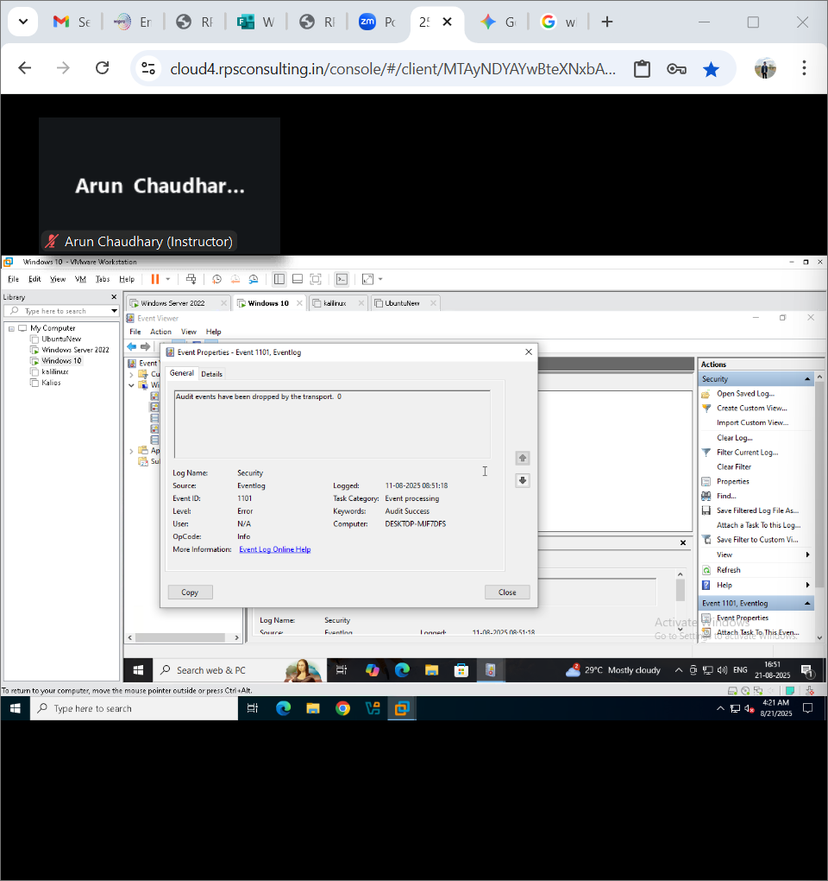
Event Id : 1101 – It audit events have been dropped by the transport mechanism, meaning the system was unable to log all audit events
Step 6 click on Setup and click on Filter Current Log [ right side ]
- Select Critical , Error and Warning
- Click ok
If any error done during the setup, you will find the log else there will be no error logs
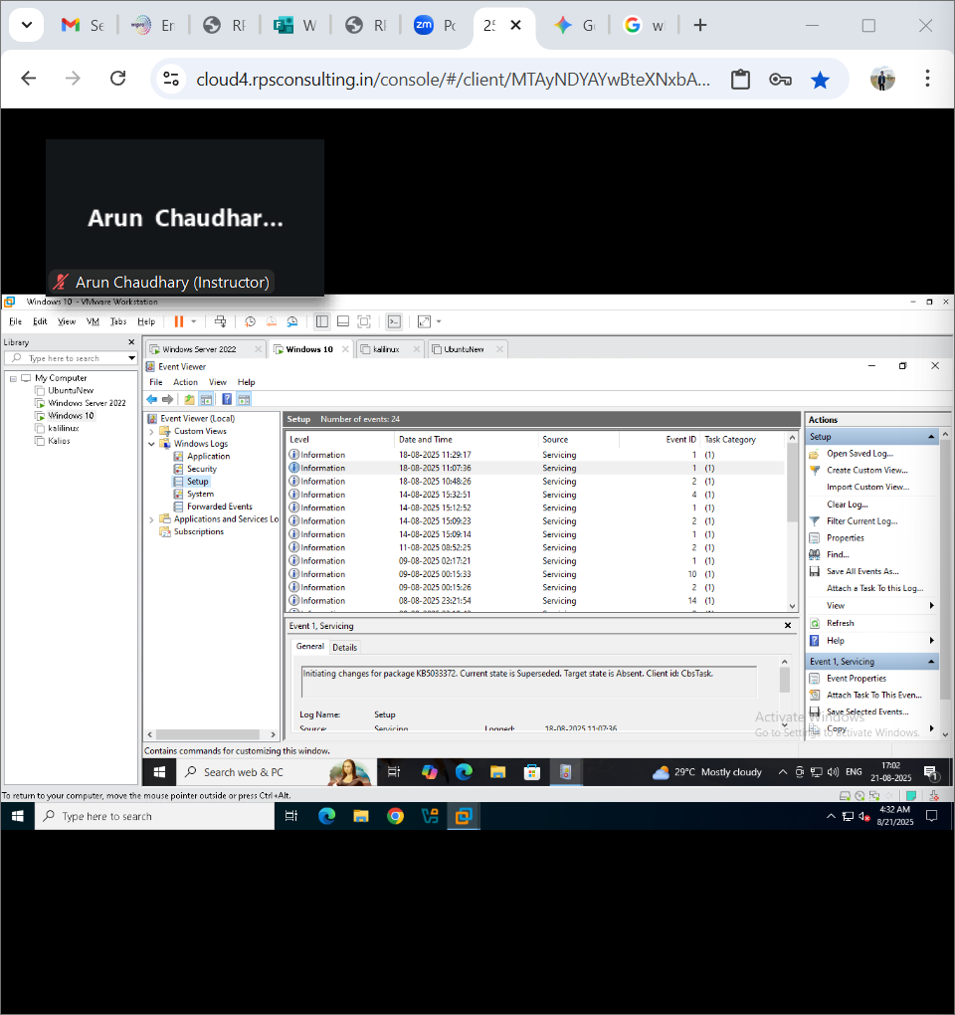
Step 7 click on Setup and click on Filter Current Log [ right side ]
- Select Critical , Error and Warning
- Click ok
Event ID : 10010 – It indicates that a server failed to register with DCOM within the allotted time

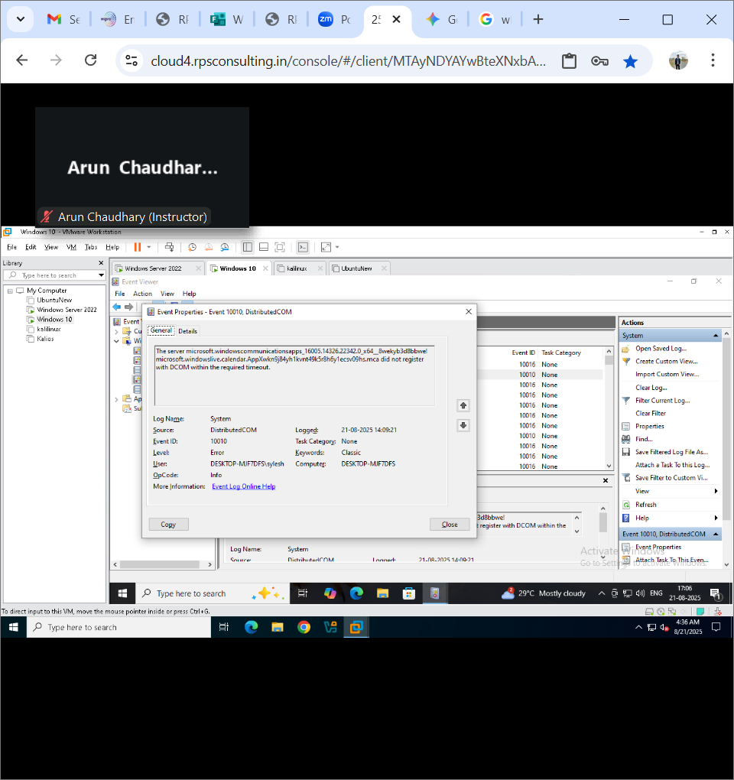
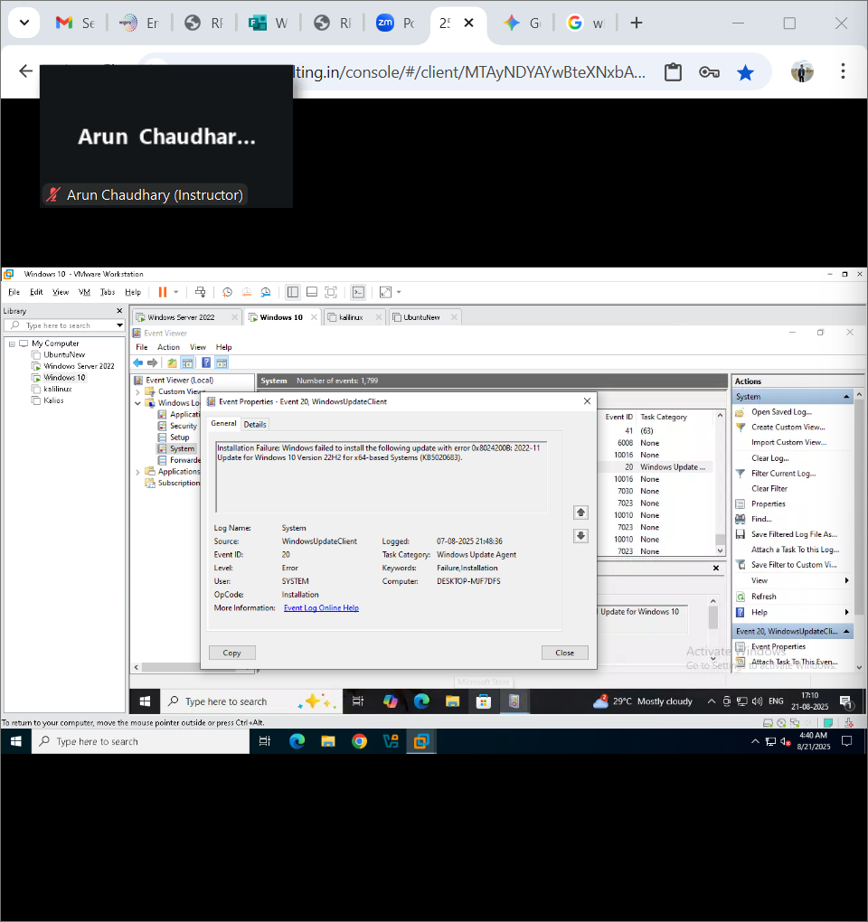
Event ID : 20 – It indicates Windows Update failures from the Windows Update Client
Step 8 click on Forwarded Events and click on Filter Current Log [ right side ]
- Select Critical , Error and Warning
- Click ok
If any error done during the Remote Session, you will find the log else there will be no error logs
